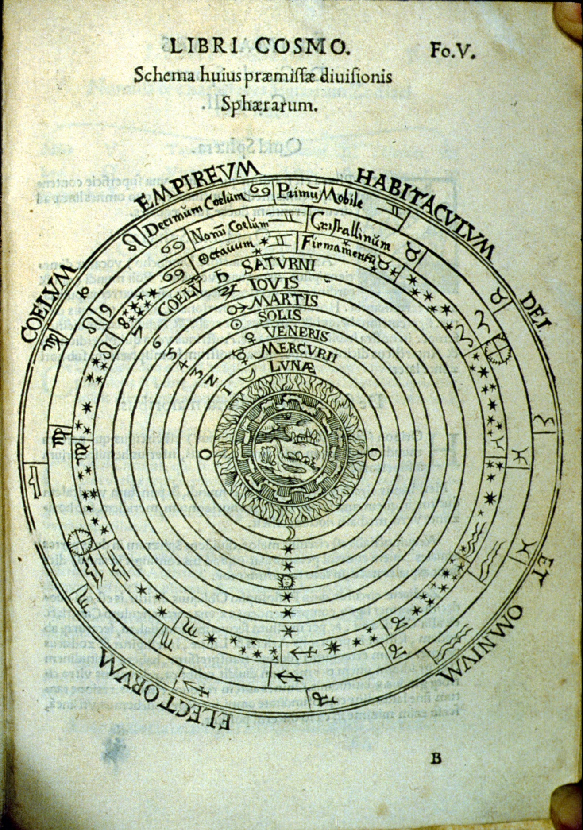

Aristotelian cosmos from Peter Apian, *Cosmographicus liber*, Antwerp 1584. Image courtesy of the History of Science Collections, University of Oklahoma Libraries.